Oblique Shock Wave Analysis Over a Two-Dimensional Wedge: Analytical, Computational, and Experimental Comparison

By: Aurian Malhotra

Department of Mechanical and Aerospace Engineering
University of California, Davis
EAE 198 - Compressible Flow Aerodynamics

June 1, 2026

Introduction

Oblique shock waves are a fundamental phenomenon in supersonic aerodynamics, arising whenever a supersonic flow encounters a surface deflection such as a wedge or ramp. Unlike normal shocks, which are always detached and produce a subsonic downstream flow, oblique shocks attach to the leading edge of a wedge and can produce either supersonic or subsonic flow downstream depending on the shock strength. The relationship between the upstream Mach number M₁, the wedge half-angle 𝛩, and the resulting shock wave angle 𝛽 is governed by the 𝛩-𝛽-M relation, which forms the theoretical foundation of this study.

This project investigates oblique shock behavior over a two-dimensional wedge across three upstream Mach numbers (M = 2, 2.5, and 3) and three wedge half-angles (𝛩 = 5°, 10°, and 15°), for a total of nine flow conditions. Three independent methods are employed and compared: analytical solution of the 𝛩-𝛽-M relation using MATLAB, computational fluid dynamics (CFD) simulation using ANSYS Fluent, and experimental measurement via Schlieren photography. The shock wave angle 𝛽 is extracted from each method and plotted together on a 𝛩-𝛽-M diagram to assess agreement across all three approaches. Additionally, Schlieren images and CFD Mach contour plots are compared qualitatively for each condition to validate the computational results against experimental.

Methodology

- Analytical

The theoretical shock wave angle $β$ was determined by numerically solving the 𝛩-𝛽-M relation, given by:

Equation 1: $cot Θ = tan β [\frac{(γ+1)M_{1}^{2}}{2(M_{1}^{2}\sin^{2}β - 1)}-1]$

Where 𝛾 = 1.4 for air. For each combination of Mach number and wedge angle, a MATLAB script (Figure 1) swept 𝛽 from the Mach angle 𝜇 = arcsin(1/M) to 90°, evaluated the corresponding 𝛩 at each 𝛽, and identified the weak shock solution (the lower of the two 𝛽 values satisfying the equation for a given 𝛩). The resulting 𝛽 values are reported in Tables 8-10 and are used to generate the continuous theoretical curves on the 𝛩-𝛽-M diagram (Figure 3).
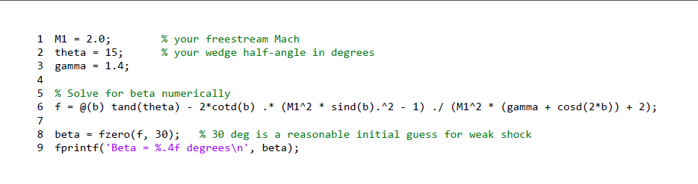
Figure 1: Analytical Beta Calculator

- Computational

Supersonic flow over a two-dimensional wedge was simulated using ANSYS Fluent for all nine conditions listed in Table 11. Each simulation used a structured quadrilateral mesh over a wedge geometry with the inlet boundary condition set to the specified freestream Mach number, a static pressure of 1 atm, and a static temperature of 300 K. The density-based solver was used with a second-order upwind scheme. Once converged, Mach number contour plots were extracted for each case and are provided in the Appendix. The shock wave angle 𝛽 was measured from each contour by identifying two coordinates along the shock wave and applying:

Equation 2: $β = \tan^{-1}(\frac{Δy}{Δx})$

Where $Δ$y and $Δ$x are the vertical and horizontal separations between the two points. The resulting CFD 𝛽 values are reported in Tables 4-6.

- Experimental

The experimental data were obtained using Schlieren photography of supersonic flow over a wedge in the NCSU supersonic wind tunnel. The Schlieren technique exploits the dependence of the refractive index of air on density - as a shock wave produces a sharp density gradient, it deflects light passing through the test section, producing a visible dark band on the recorded image. The Schlieren system (Figure 2) consists of a coherent light source, a slit, two concave mirrors, a knife edge at the focal point, and a recording device.
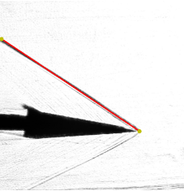
Figure 2: Schlieren System Schematic

The shock wave angle 𝛽 was extracted from each Schlieren image using the same coordinate method applied to the CFD contours. Two points were identified along the upper oblique shock wave in each image, and 𝛽 was computed as Equation 2. Where $Δ$y and $Δ$x are the pixel coordinate differences between two selected points. Since only the ratio of pixel distances enters the calculation, no physical length calibration of the images is required. The resulting experimental 𝛽 values are reported in Tables 1-3.

Results and Discussion

- 𝛩-𝛽-M Comparison

The shock wave angles obtained from all three methods are summarized in Tables 1-9 and are co-plotted against the theoretical 𝛩-𝛽-M curves in Figure 3. In general, the analytical and CFD results show agreement across all nine conditions, with differences of less than 1° in every case. This is expected, as both methods solve the same governing equations. The CFD simulation numerically resolves the Euler equations over the wedge geometry, and for an inviscid attached oblique shock the 𝛩-𝛽-M relation is the exact analytical solution. The close agreement between the two validates the ANSYS Fluent setup and confirms that the computational mesh and boundary conditions were appropriate for each simulated condition.

Table 1: Shock Angles From Schlieren Images Mach 2
Deflection Angle 𝛩 (°) | Shock Angle 𝛽 (°)
5 | 34.7
10 | 38.3
15 | 44.1

Table 2: Shock Angles From Schlieren Images Mach 2.5
Deflection Angle 𝛩 (°) | Shock Angle 𝛽 (°)
5 | 26
10 | 30.5
15 | 35.5

Table 3: Shock Angles From Schlieren Images Mach 3
Deflection Angle 𝛩 (°) | Shock Angle 𝛽 (°)
5 | 23.9
10 | 26.1
15 | 31.3

Table 4: Shock Angles From CFD Mach 2
Deflection Angle 𝛩 (°) | Shock Angle 𝛽 (°)
5 | 34.7752
10 | 39.3111
15 | 44.3681

Table 5: Shock Angles From CFD Mach 2.5
Deflection Angle 𝛩 (°) | Shock Angle 𝛽 (°)
5 | 27.6679
10 | 31.9887
15 | 37.4365

Table 6: Shock Angles From CFD Mach 3
Deflection Angle 𝛩 (°) | Shock Angle 𝛽 (°)
5 | 22.84
10 | 28.103
15 | 32.42

Table 7: Analytical Shock Angles From MATLAB, Mach 2
Deflection Angle 𝛩 (°) | Shock Angle 𝛽 (°)
5 | 34.3016
10 | 39.3139
15 | 45.3436

Table 8: Analytical Shock Angles From MATLAB, Mach 2.5
Deflection Angle 𝛩 (°) | Shock Angle 𝛽 (°)
5 | 27.4227
10 | 31.8506
15 | 36.9449

Table 9: Analytical Shock Angles From MATLAB, Mach 3
Deflection Angle 𝛩 (°) | Shock Angle 𝛽 (°)
5 | 23.1333
10 | 27.3827
15 | 32.2404

The experimental Schlieren measurements show strong agreement with theory for the M = 2 cases, with 𝛽 values of 34.7°, 38.3°, and 44.1° for 𝛩 = 5°, 10°, and 15° respectively, compared to analytical values of 34.3°, 39.3°, and 45.3°. The M = 3 cases also compare reasonably well, with measured values of 23.9°, 26.1°, and 31.3° against analytical values of 23.1°, 27.4°, and 32.2°, yielding errors within approximately 2° for all three conditions. The M = 2.5 results show a consistent underprediction of approximately 1.5° to 2.5° across all three wedge angles, with measured values of 26.0°, 30.5°, and 35.5° compared to analytical values of 27.4°, 31.9°, and 36.9°. While smaller in magnitude than the M = 2 and M = 3 discrepancies, the consistent directional offset across all three wedge angles at this Mach number suggests a mild systematic source of error, likely related to perspective or image quality for that image set, rather than random pixel measurement uncertainty.

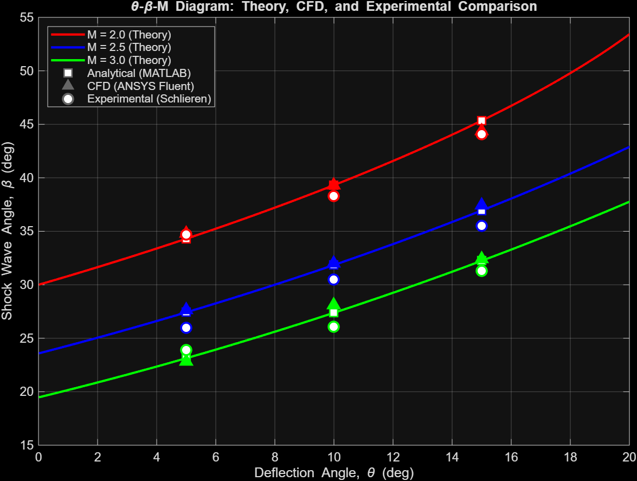
Figure 3: 𝛩-𝛽-M Diagram Comparing Analytical, CFD, and Experimental Shock Angles

Across all Mach numbers, a consistent physical trend is observed: for a fixed Mach number, 𝛽 increases with 𝛩, and for a fixed 𝛩, 𝛽 decreases as Mach number increases. Both trends are well captured by all three methods and are consistent with the 𝛩-𝛽-M relation. The decrease in 𝛽 with increasing Mach number reflects the fact that at higher speeds the flow requires a shallower shock angle to turn through the same deflection angle.

- Schlieren and CFD Comparison

Table 10 presents the Schlieren images alongside the corresponding ANSYS Fluent Mach contour plots for all nine conditions. In each case the CFD contour clearly shows a sharp oblique shock emanating from the wedge tip, with a distinct jump from the freestream Mach number upstream to a lower Mach number downstream of the shock. The Schlieren images show the same feature as a dark band originating at the wedge tip, consistent with the large density gradient across the shock.

Table 10: Schlieren Images against CFD Mach Contours for Each Case
Mach 2 | 𝛩 = 5°
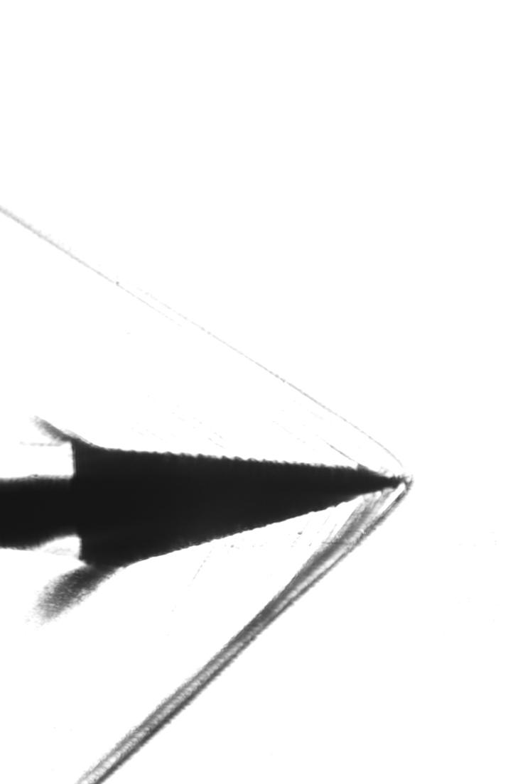 | 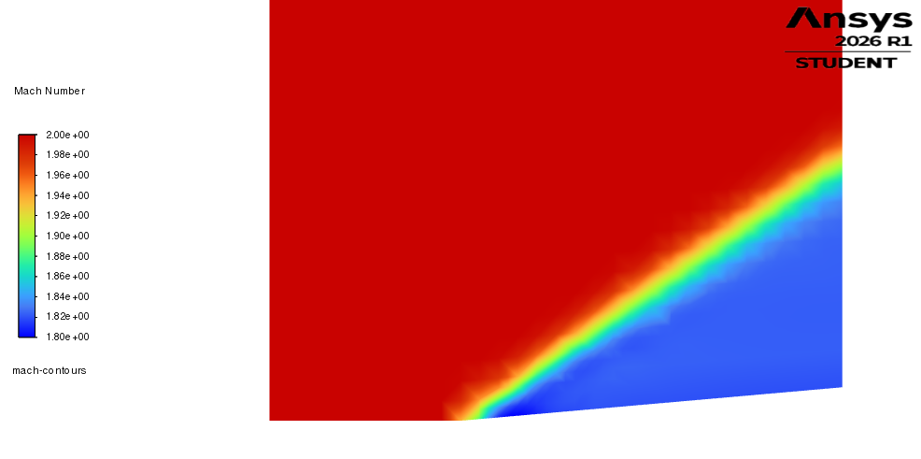
Mach 2 | 𝛩 = 10°
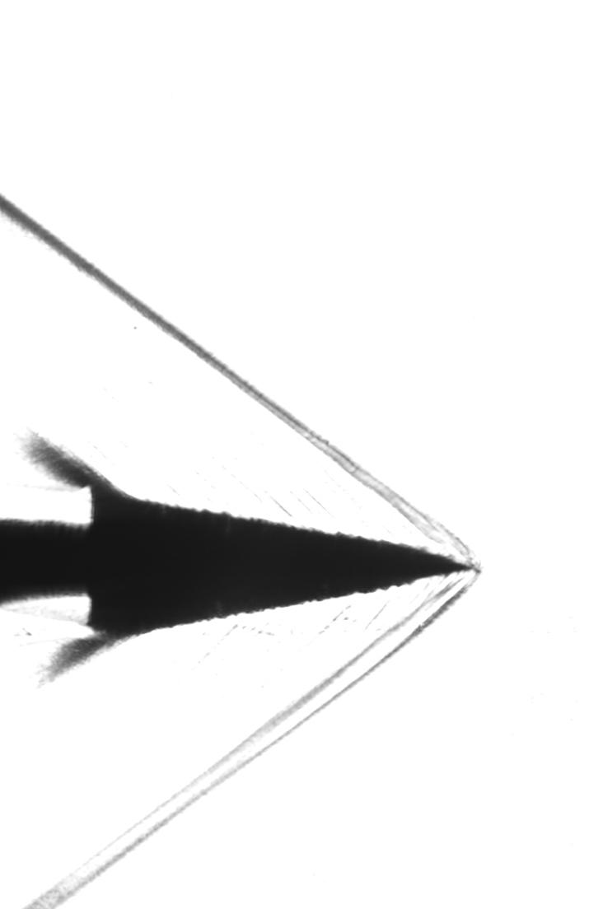 | 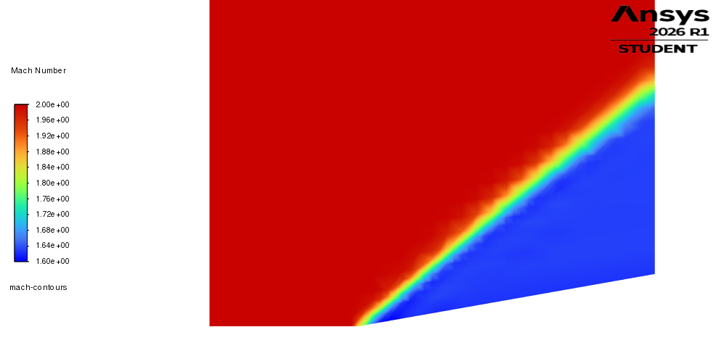
Mach 2 | 𝛩 = 15°
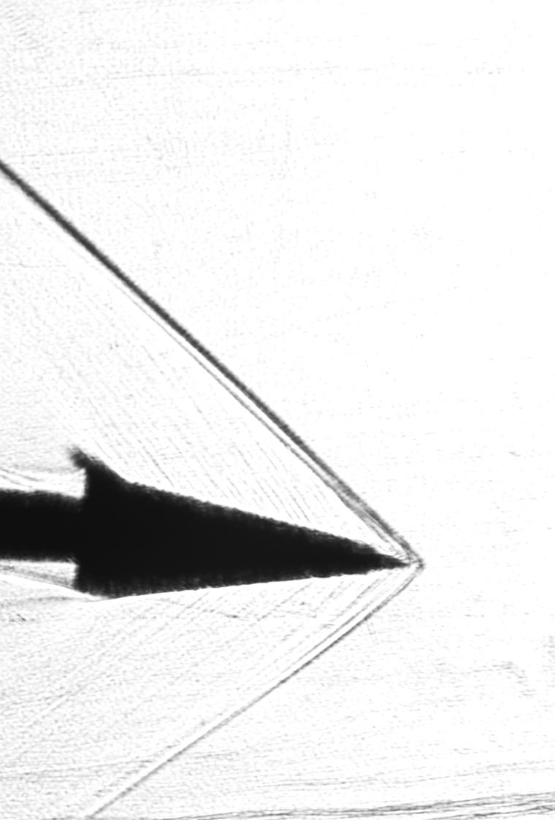 | 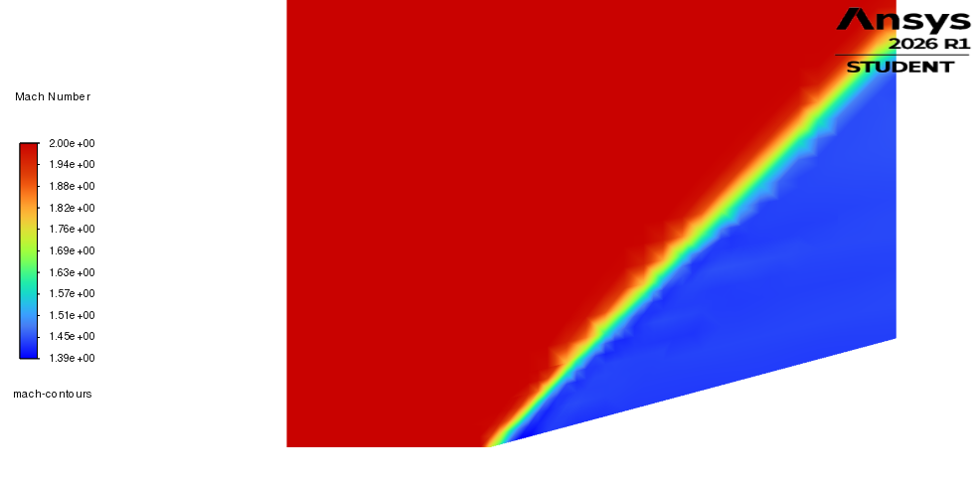
Mach 2.5 | 𝛩 = 5°
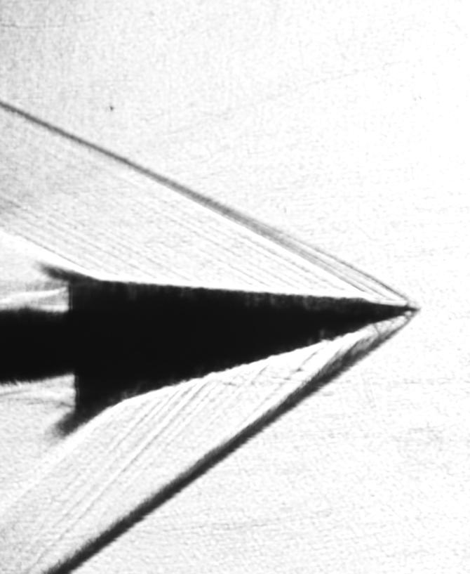 | 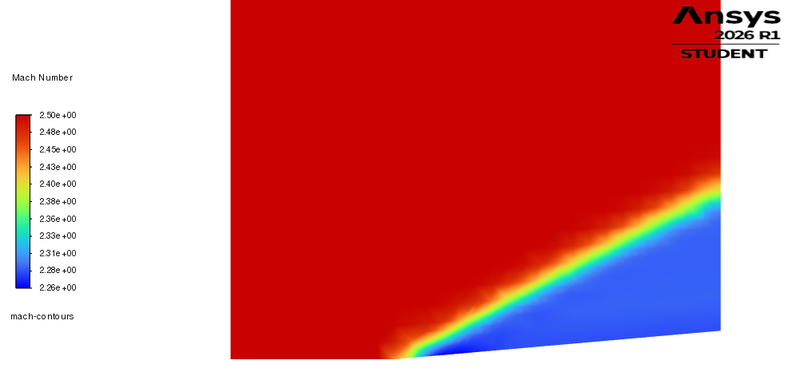
Mach 2.5 | 𝛩 = 10°
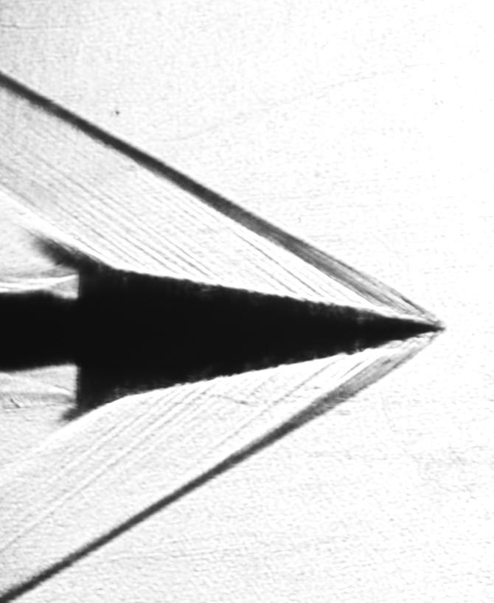 | 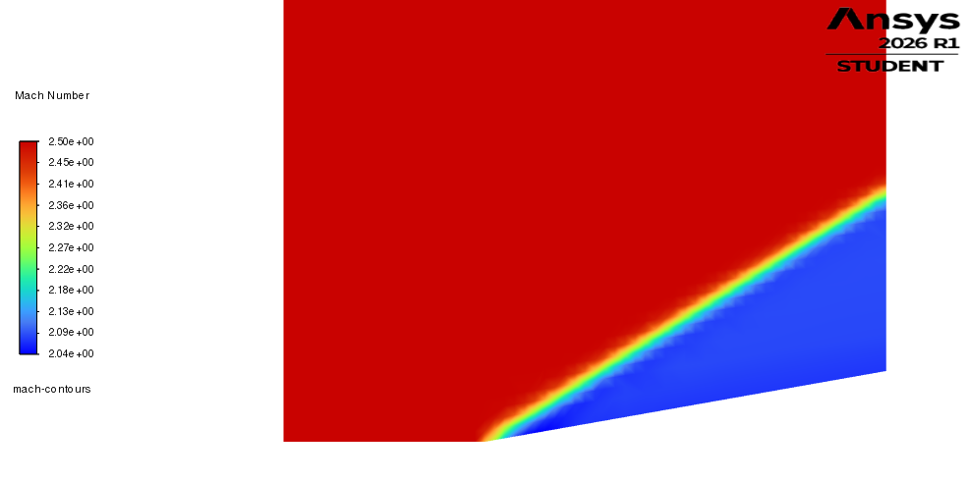
Mach 2.5 | 𝛩 = 15°
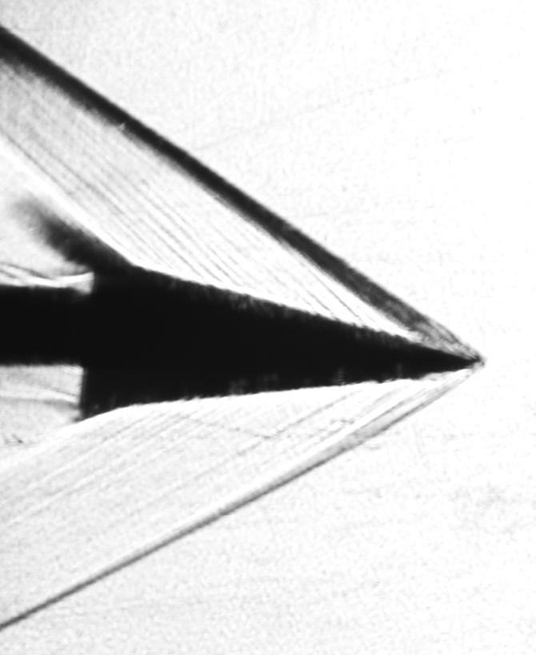 | 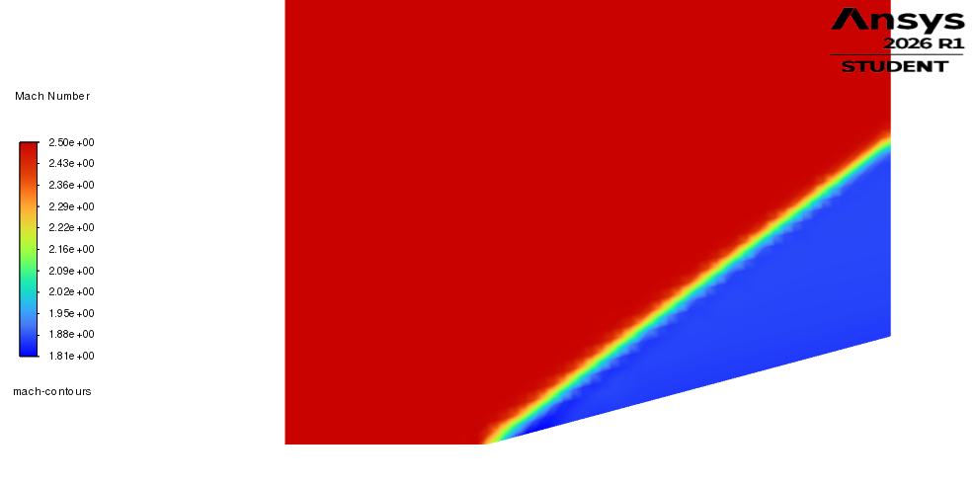
Mach 3 | 𝛩 = 5°
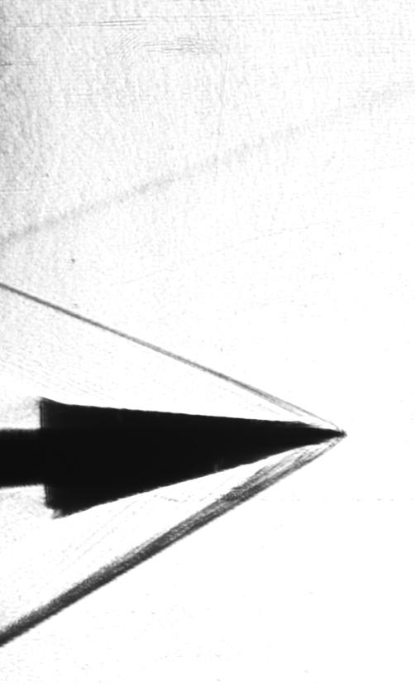 | 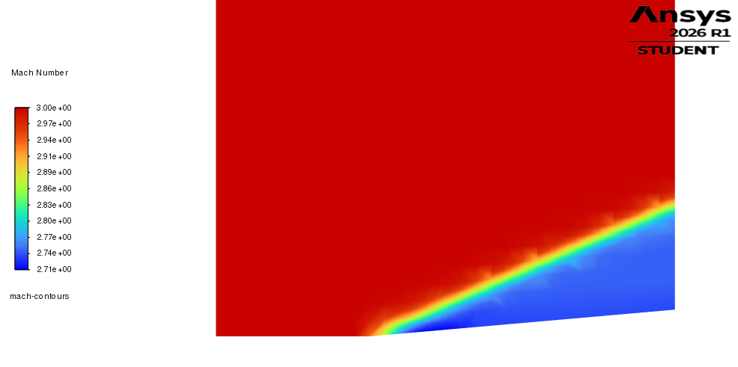
Mach 3 | 𝛩 = 10°
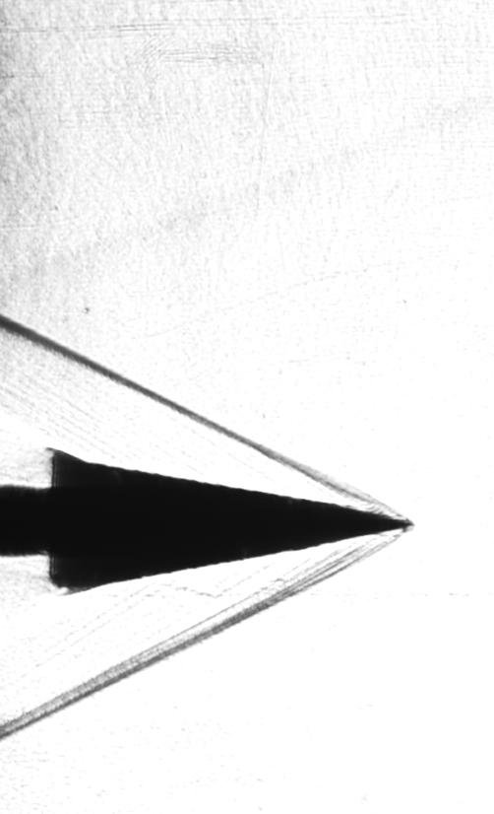 | 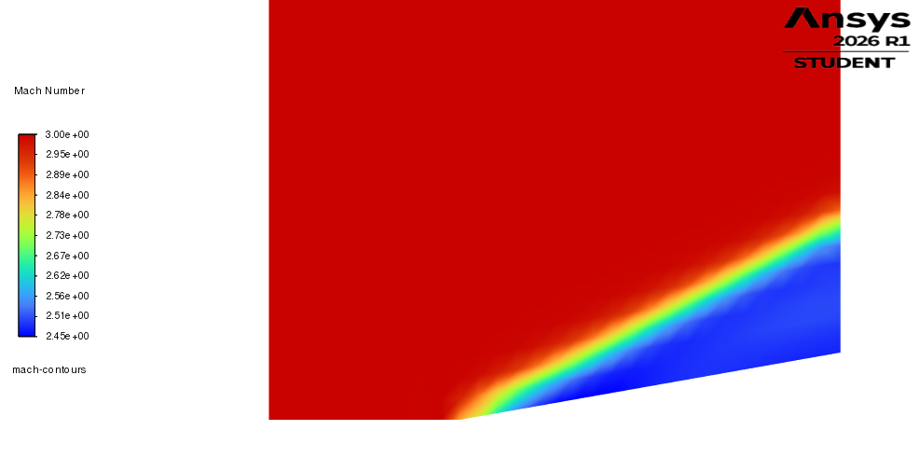
Mach 3 | 𝛩 = 15°
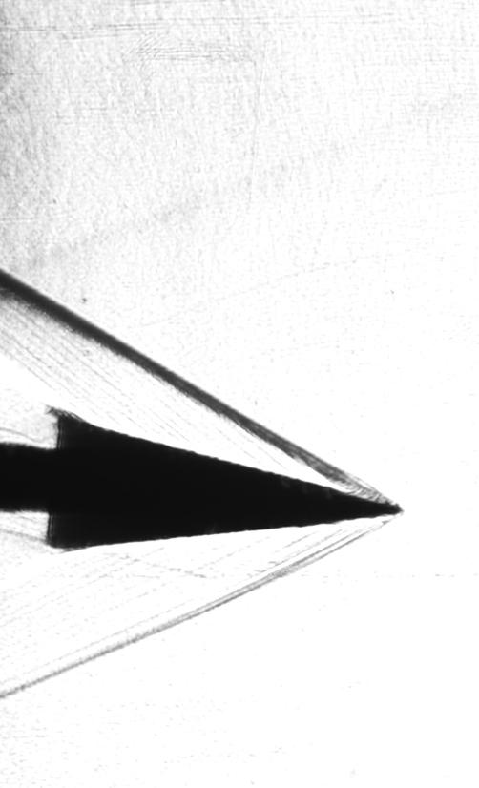 | 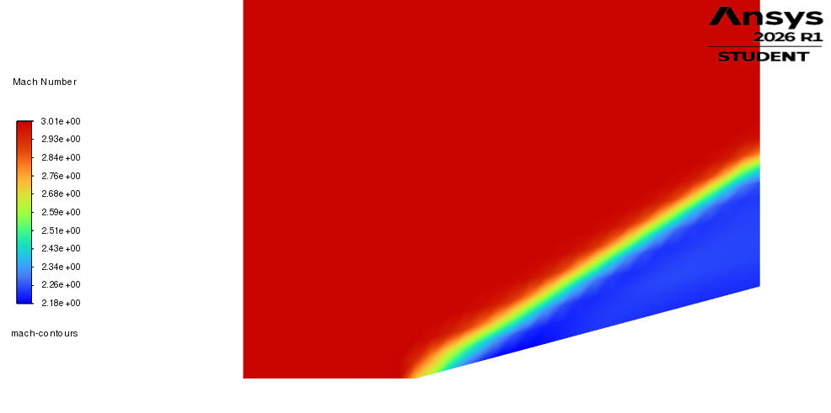

For the M = 2 cases the shock wave is visually prominent in both the Schlieren images and the CFD contours, and the shock angle increases noticeably as 𝛩 increases from 5° to 15°, in agreement with the quantitative measurements. For M = 2.5 and M = 3, the shock angle is shallower relative to the freestream direction, which is visible in both the Schlieren images and the contour plots, with the shock wave sitting closer to the wedge surface as Mach number increases. At 𝛩 = 5° for all Mach numbers, the shock is the shallowest and most difficult to isolate in the Schlieren images due to its proximity to tunnel wall reflections and the relatively small density gradient associated with the weak shock at low deflection angles, which accounts for the larger measurement uncertainty at these conditions.

Overall the qualitative agreement between the Schlieren images and CFD contours is strong across all nine cases, confirming that the simulations accurately capture both the location and angle of the oblique shock for each combination of Mach number and wedge angle.

Conclusion

This study investigated oblique shock wave behavior over a two-dimensional wedge at Mach numbers of 2, 2.5, and 3 and wedge half-angles of 5°, 10°, and 15° using three independent methods: analytical solution of the 𝛩-𝛽-M relation via MATLAB, computational simulation using ANSYS Fluent, and experimental measurement via Schlieren photography. The shock wave angle 𝛽 was extracted from each method and compared across all nine flow conditions.

The analytical and CFD results showed excellent agreement throughout, validating the computational setup and confirming that ANSYS Fluent accurately resolves the oblique shock for the simulated conditions. The experimental Schlieren measurements agreed well with theory for M = 2 and M = 3, with most errors within 2°. The M = 2.5 results exhibited a consistent underprediction of 1.5° to 2.5° across all wedge angles, attributed to a likely systematic perspective error in that image set rather than a deficiency in the pixel coordinate measurement method. Across all conditions, the expected physical trends were confirmed: shock angle increases with wedge angle at fixed Mach number, and decreases with increasing Mach number at fixed wedge angle, both of which are well predicted by the 𝛩-𝛽-M relation.

The qualitative comparison between Schlieren images and CFD Mach contour plots further supported these findings, with both methods showing consistent shock location and angle across all nine conditions. The results demonstrate that ANSYS Fluent is an effective tool for predicting oblique shock characteristics in supersonic wedge flows, and that the Schlieren pixel coordinate method provides a reliable means of extracting quantitative shock angle data from experimental images, particularly at moderate to high deflection angles where the shock is well separated from tunnel reflections.

Appendix

CFD Results from ANSYS

ANSYS Mach 3 Plots

𝛩 = 15°
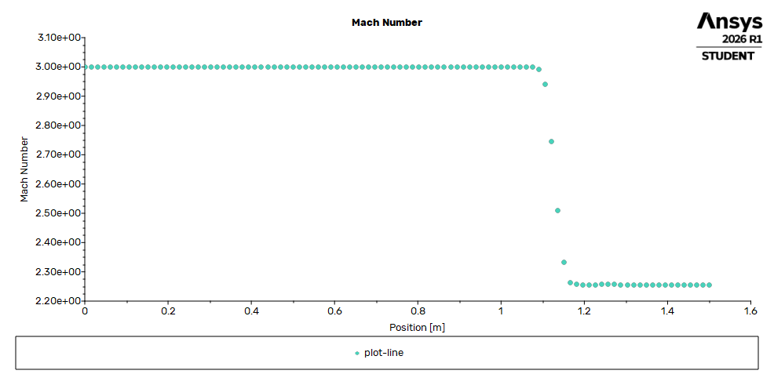


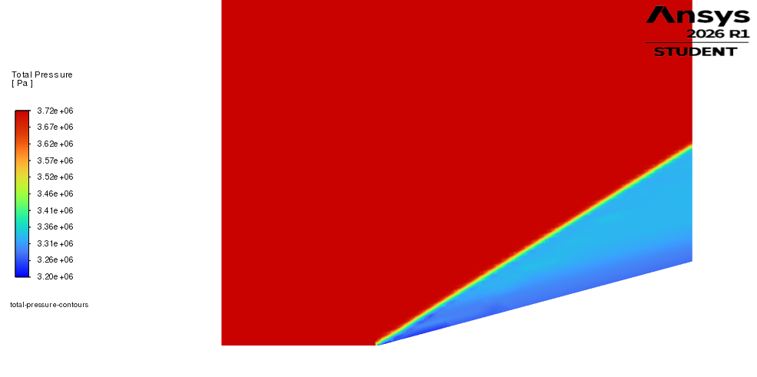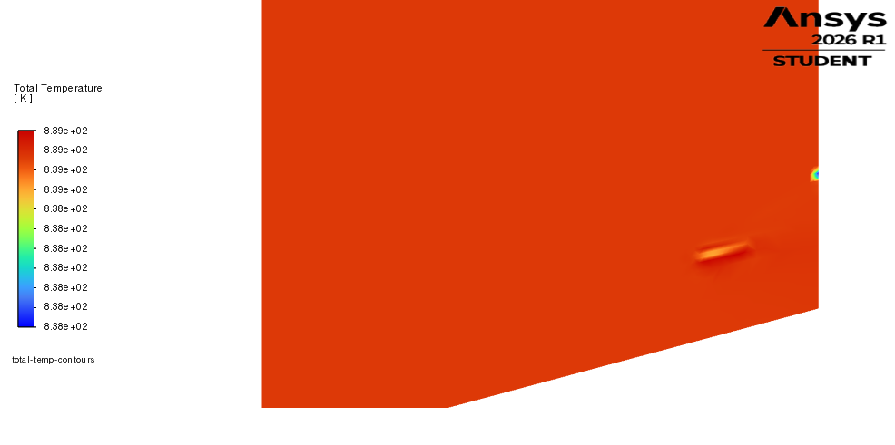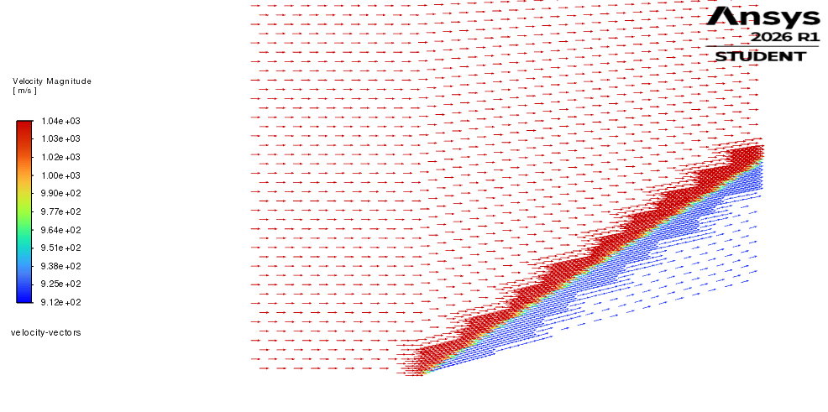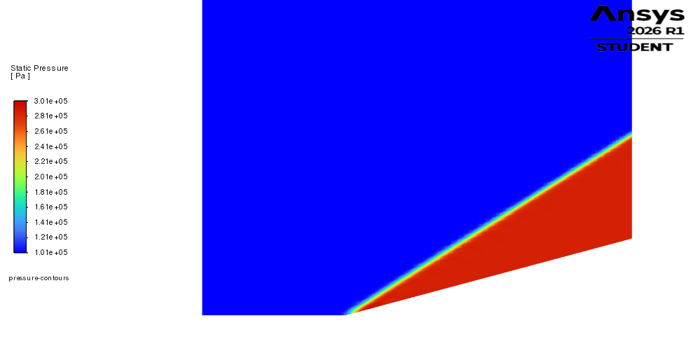

𝛩 = 10°
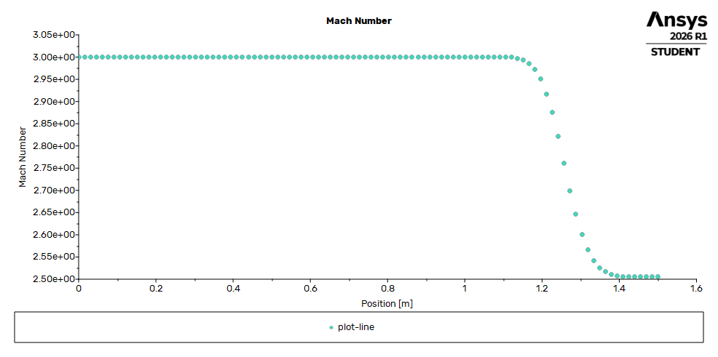
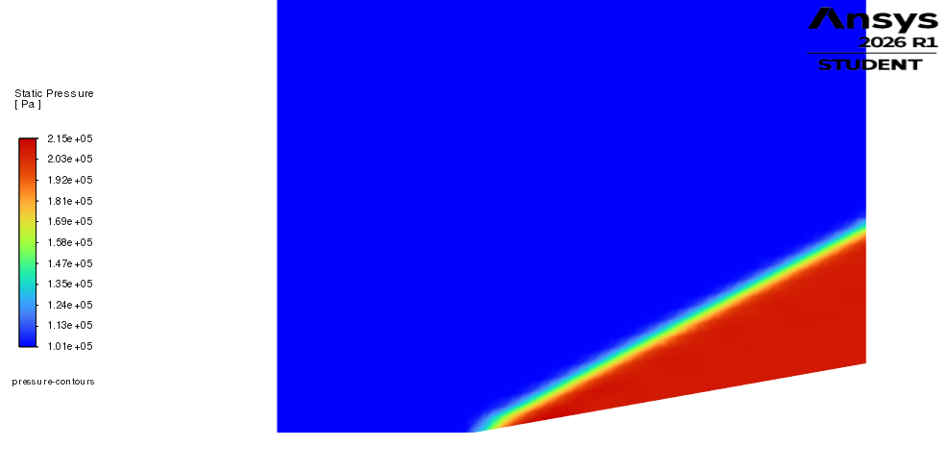
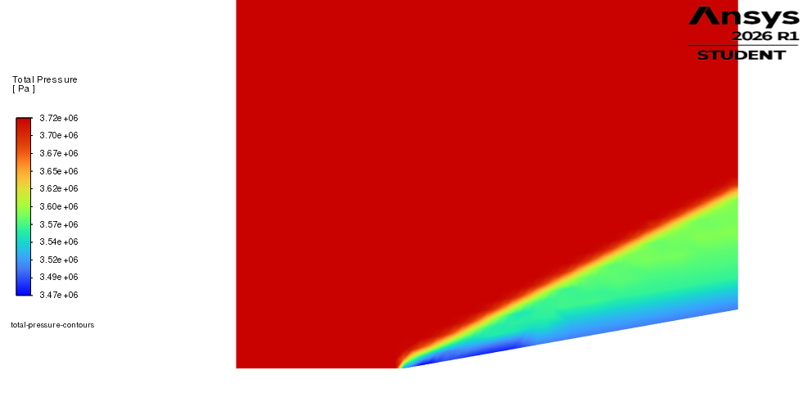
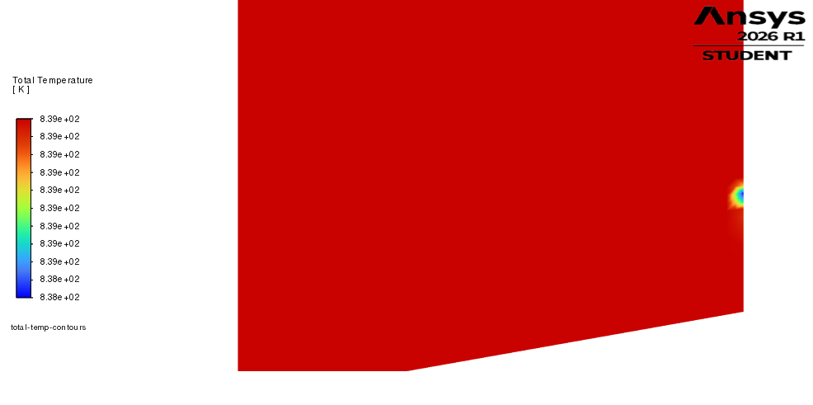
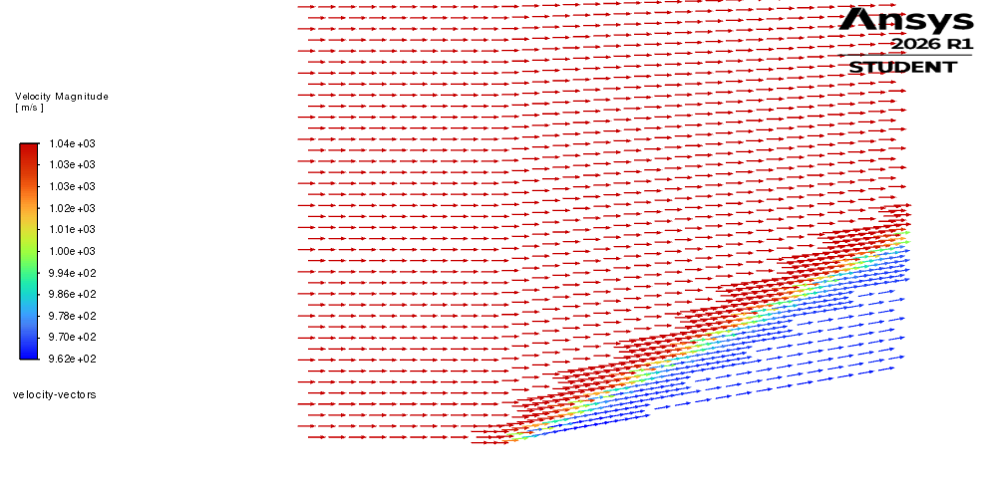

𝛩 = 5°
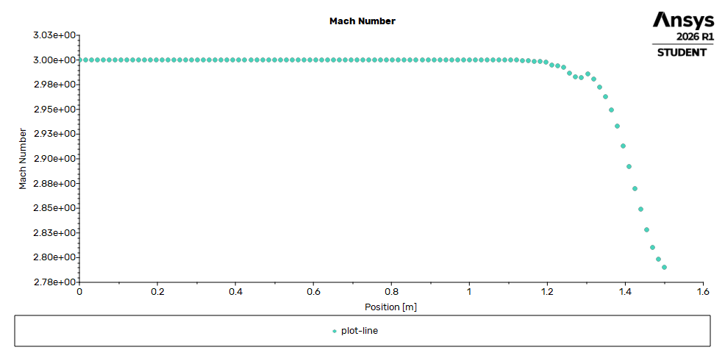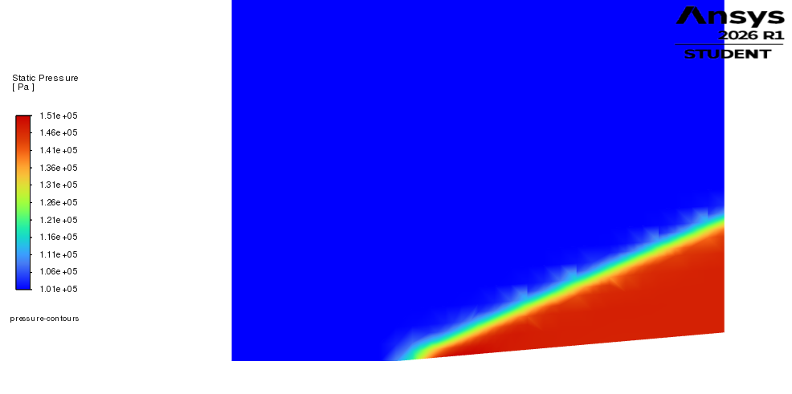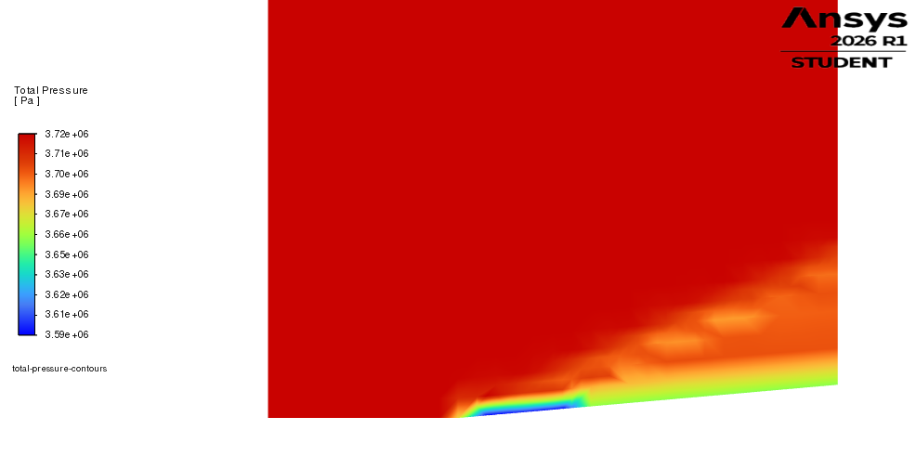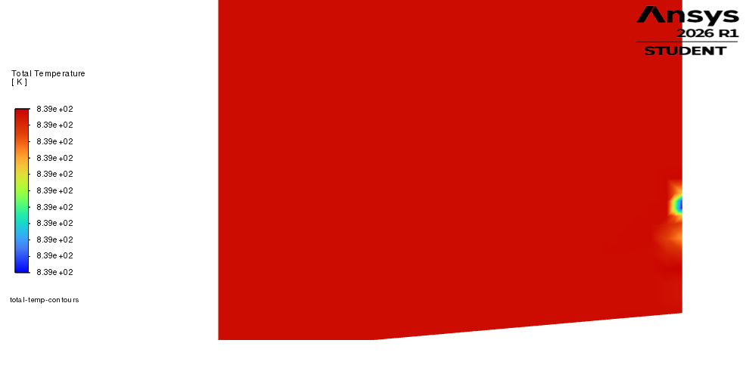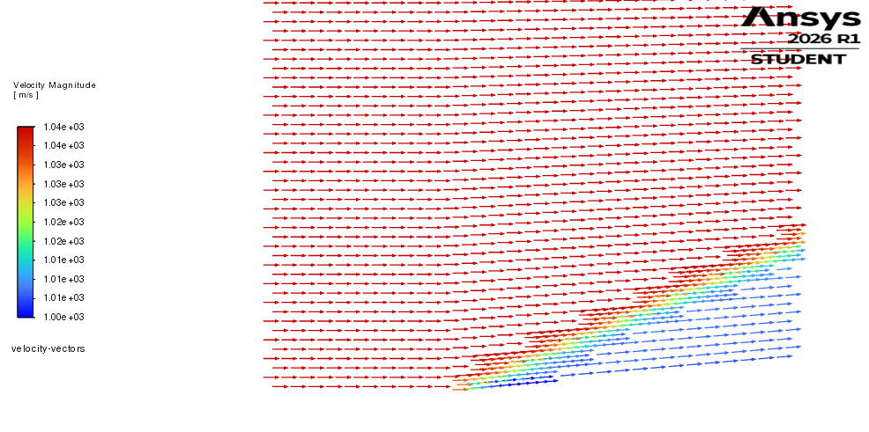

ANSYS Mach 2.5 Plots

𝛩 = 15°
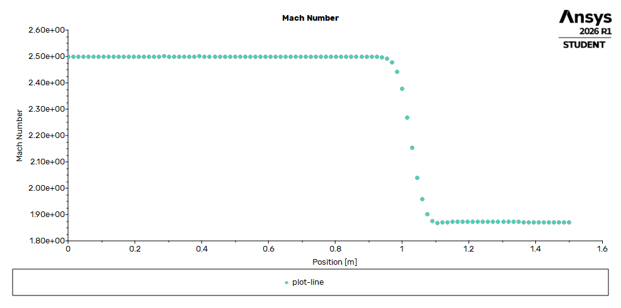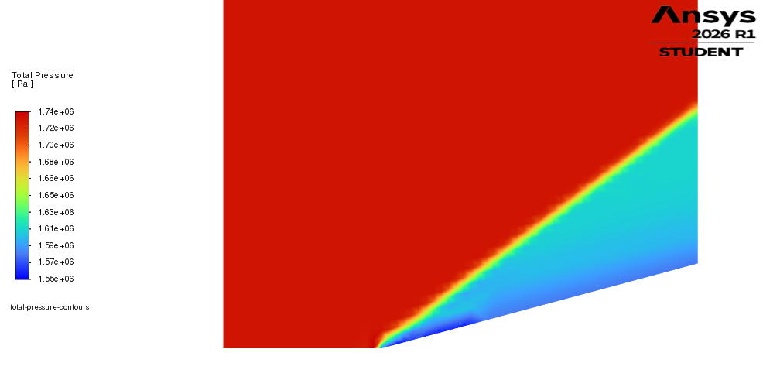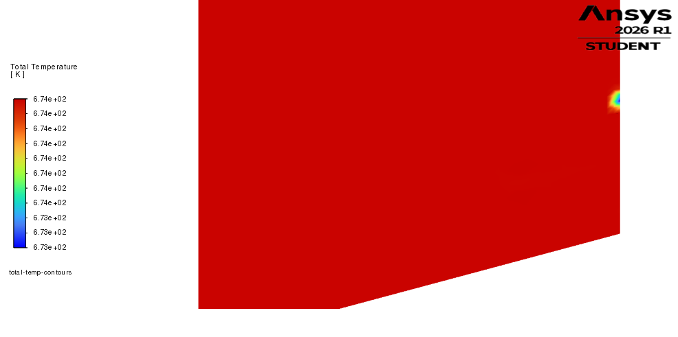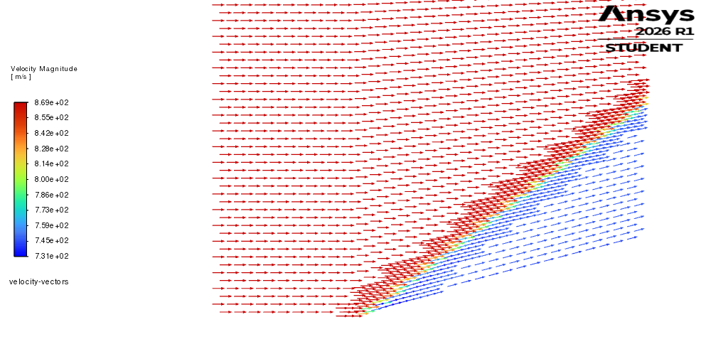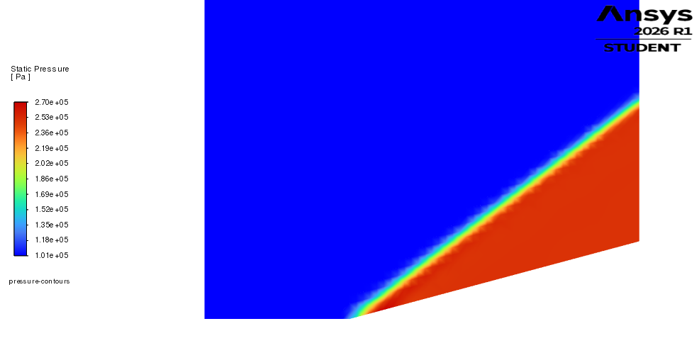

𝛩 = 10°
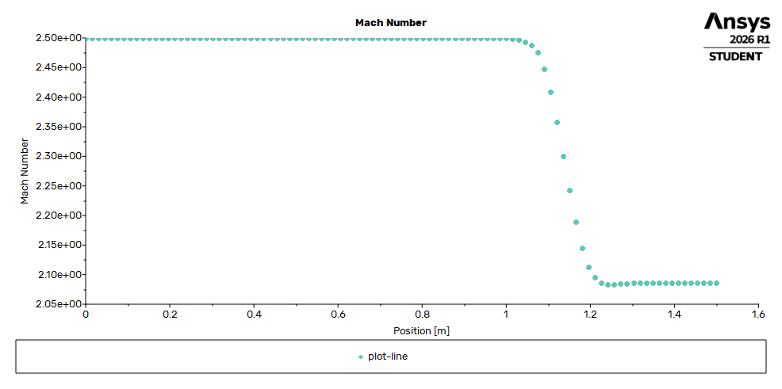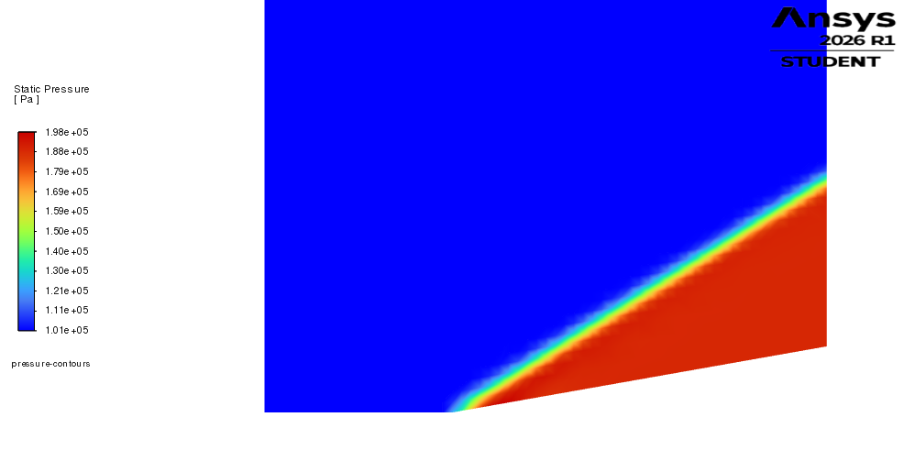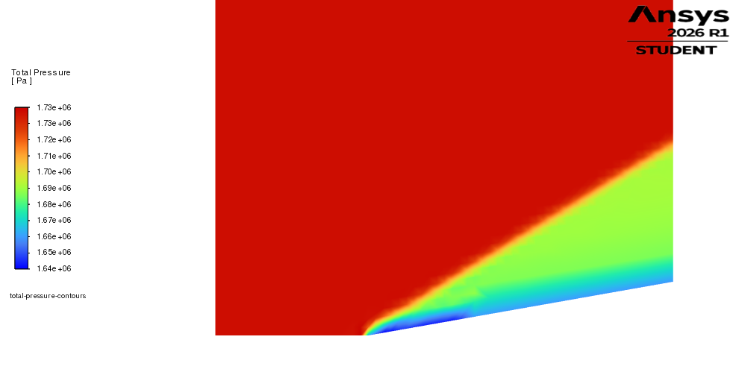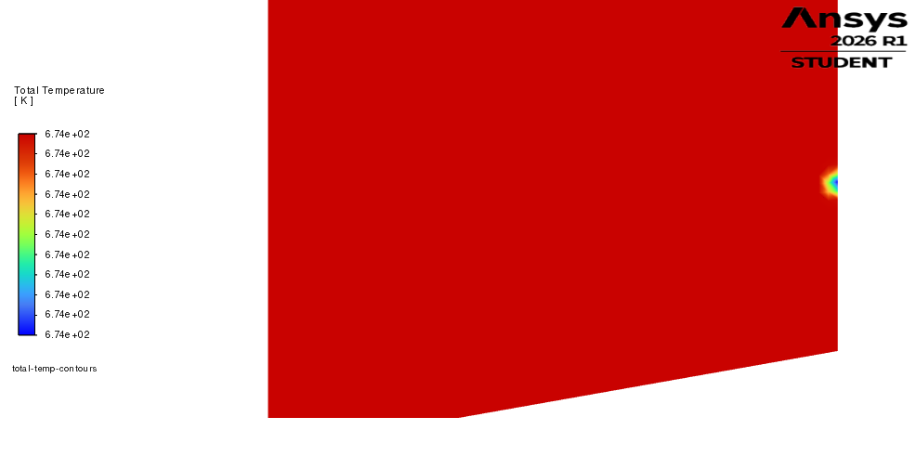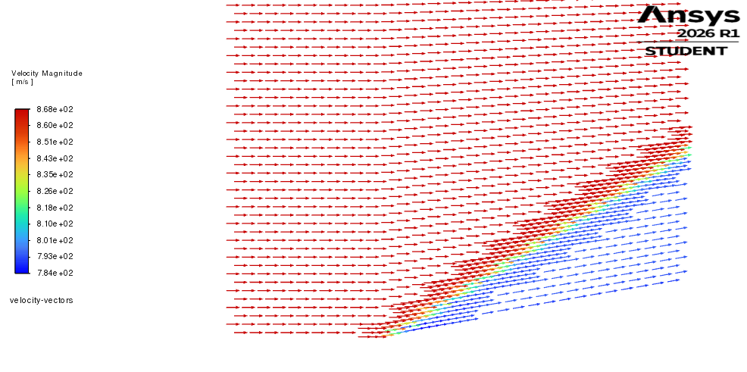

𝛩 = 5°
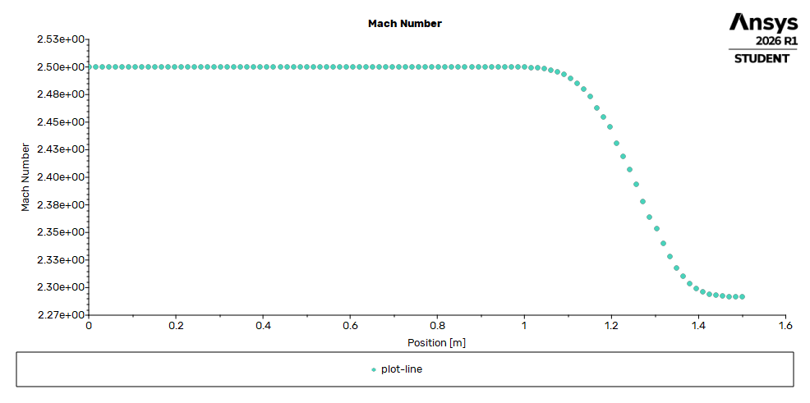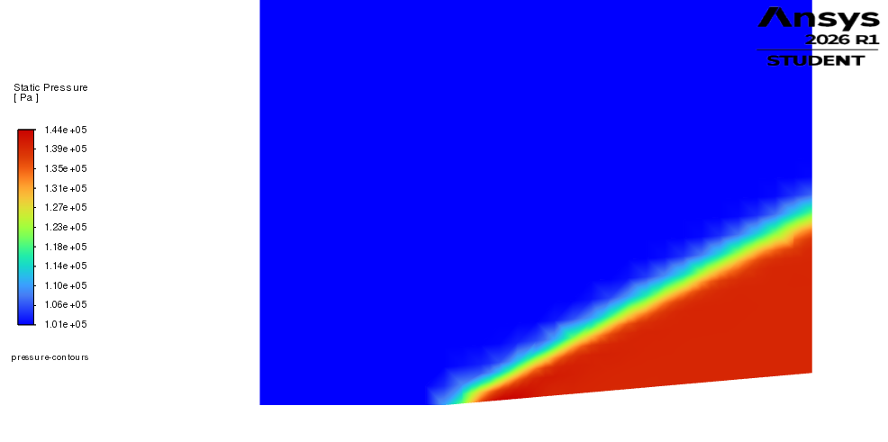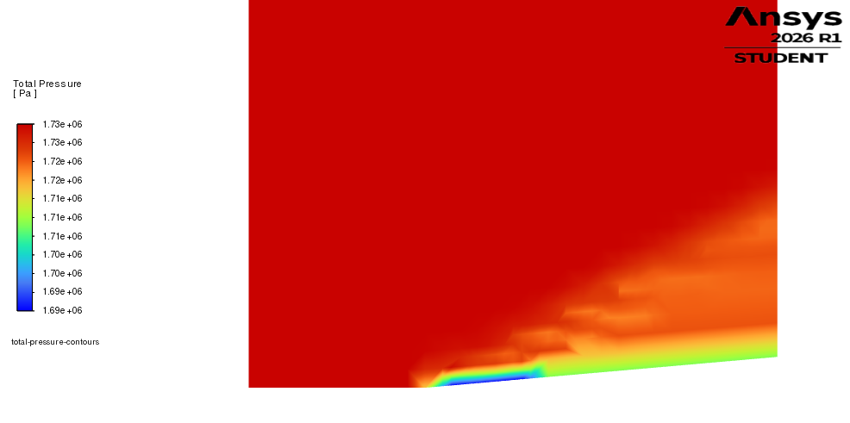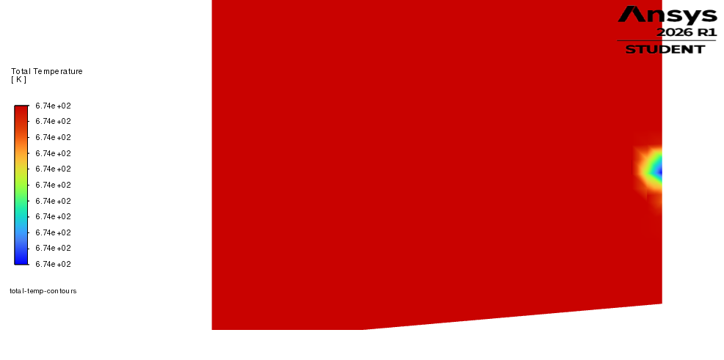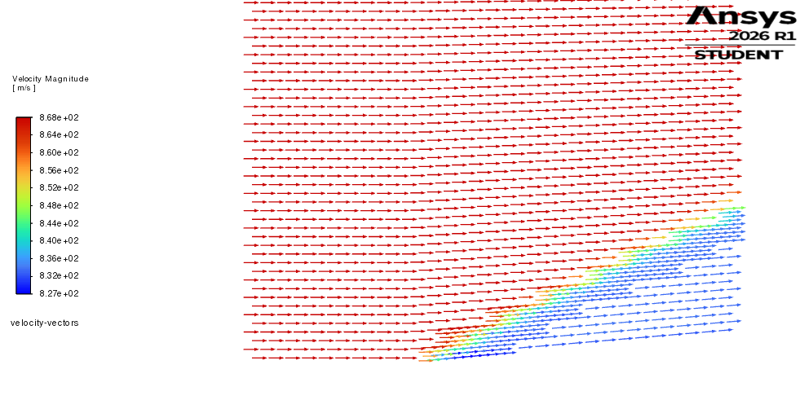

ANSYS Mach 2 Plots

𝛩 = 15°
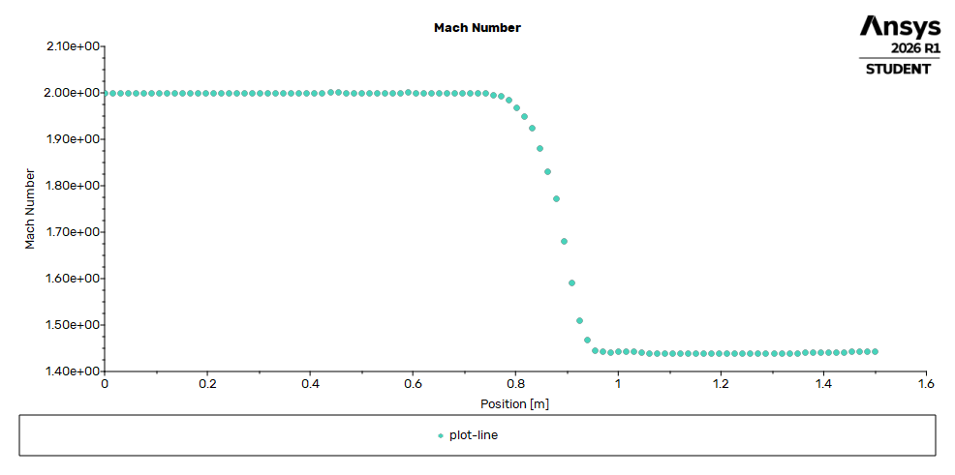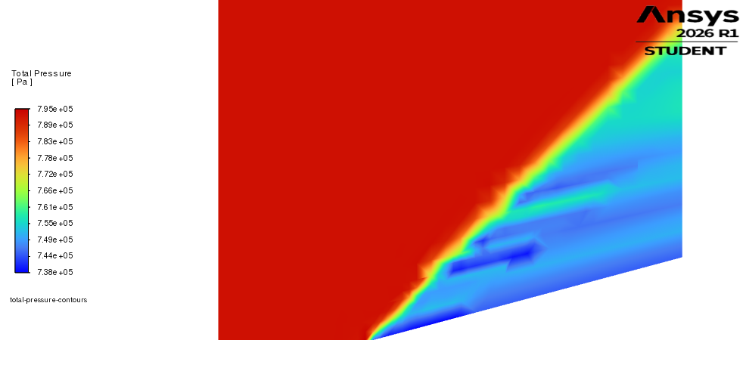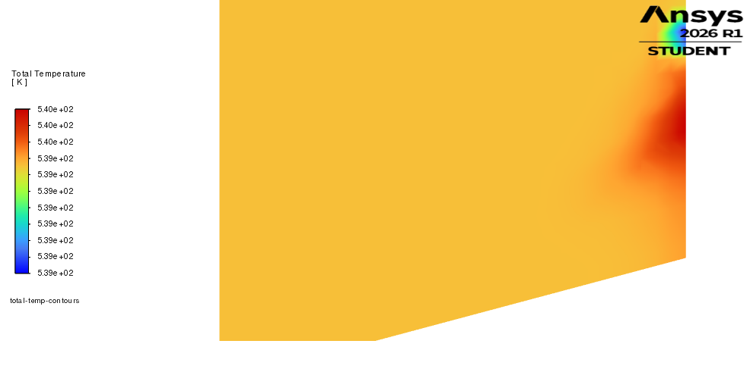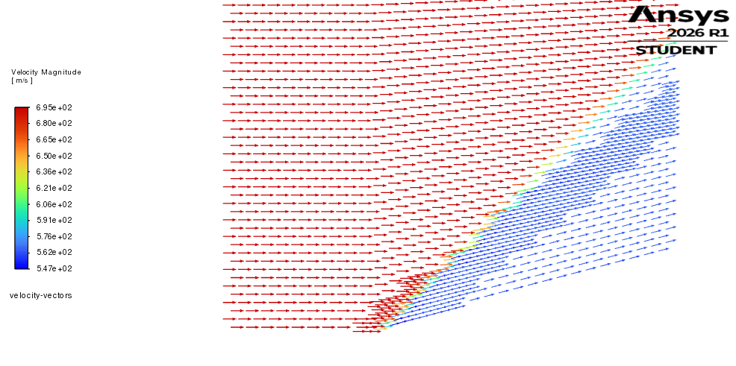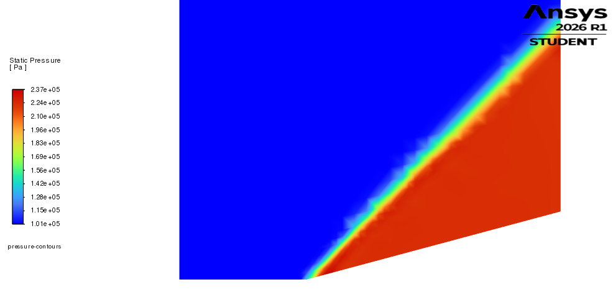

𝛩 = 10°
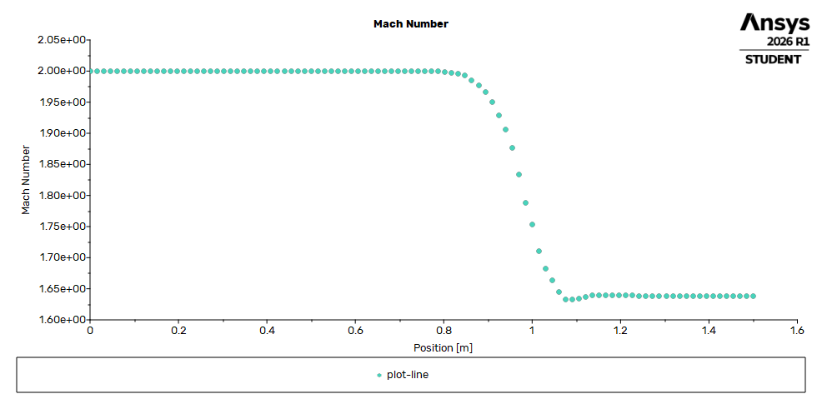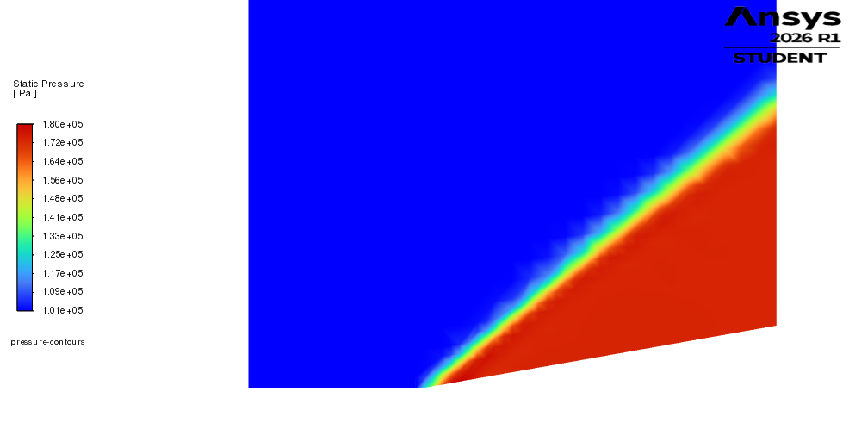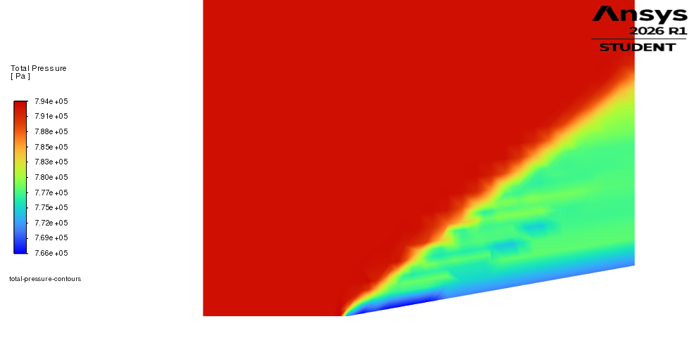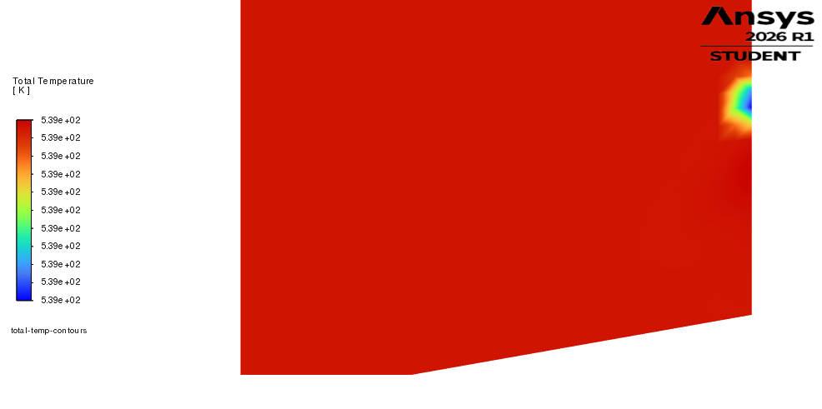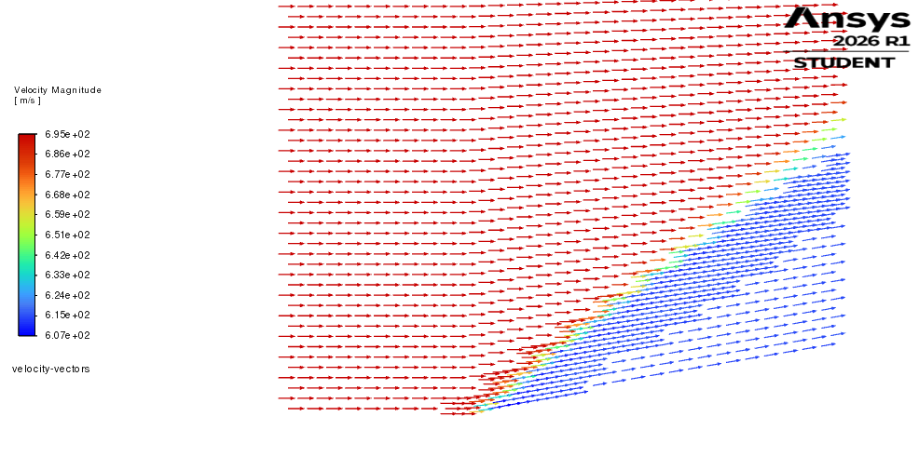

𝛩 = 5°
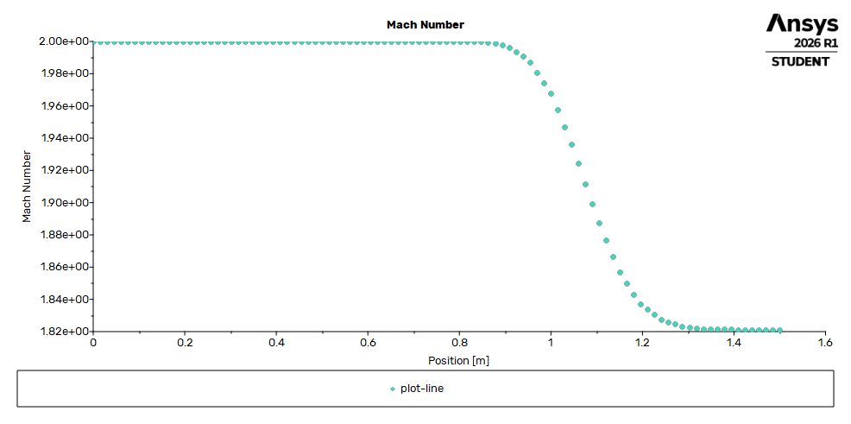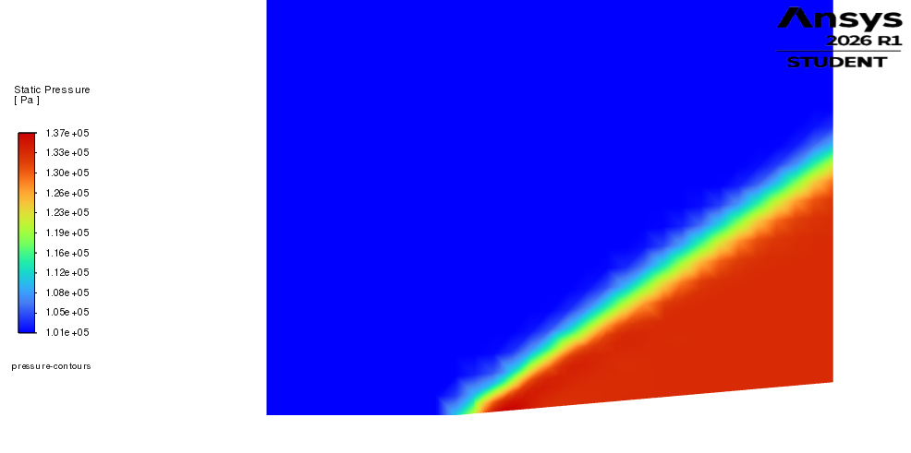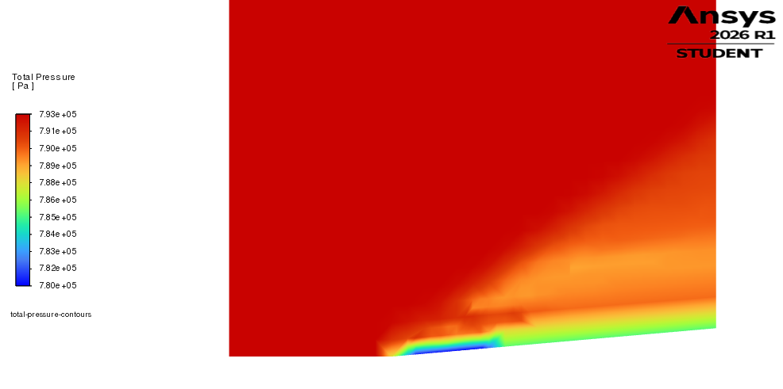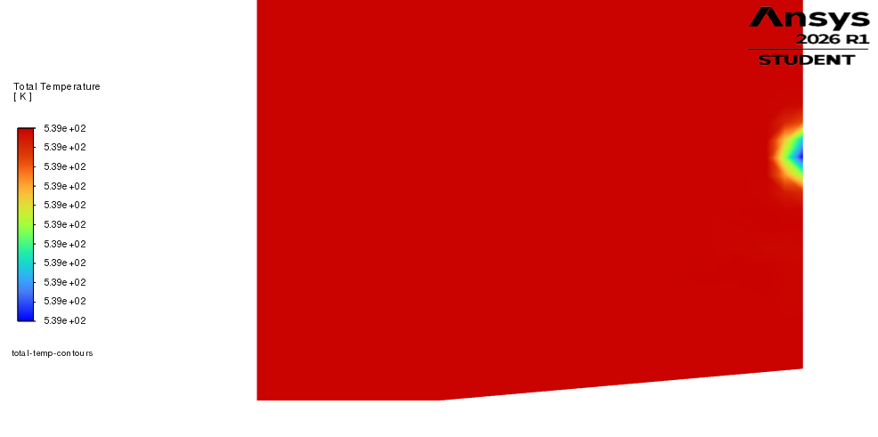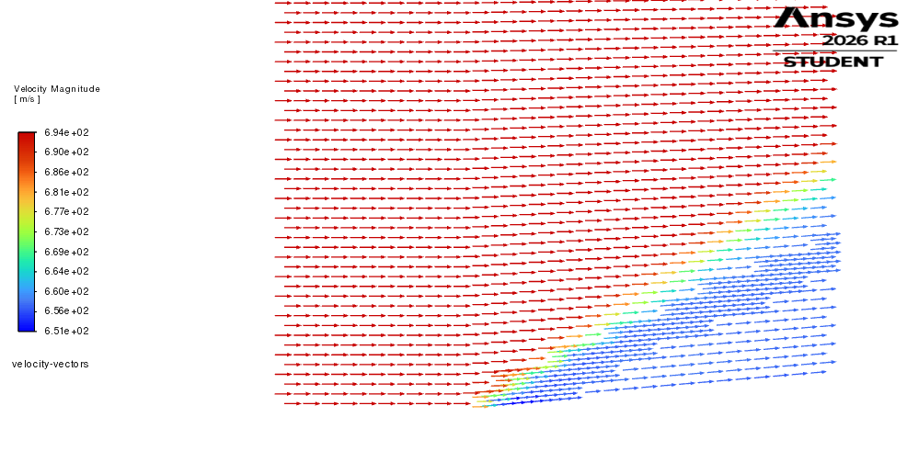

MATLAB Script for 𝛩-𝛽-M Co-Plot
